COURSE CODE: PRAC101 Section: BSIT – 4113 IM

COURSE TITLE: OJT/PRACTICUM 1

TERM: 1st Semester, SY 2024-2025

PROFESSOR: MR. EMERSON D. GELERA

DATE: November 30 2024

NAME OF STUDENT: Garth Kor-oyen

SPEAKERS NAME: Dr. Michael Angelo C. Alejandro

TITLE: Information Management in the Digital Age

**OJT NARRATIVE REPORT**

1. SCREENSHOT OF DUTY

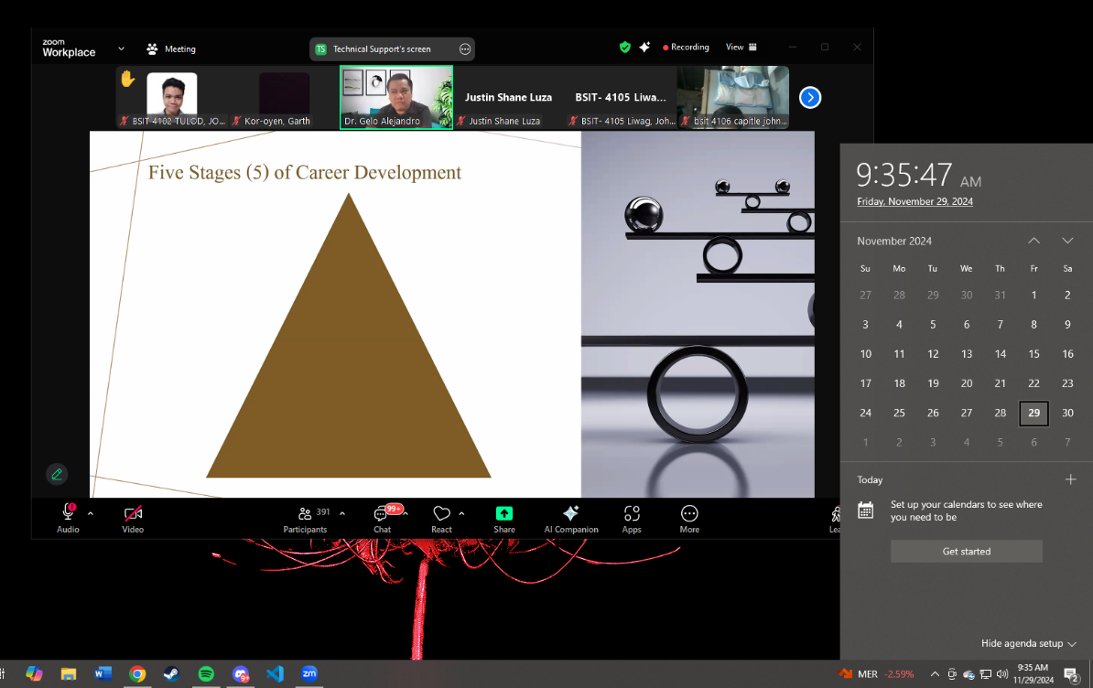

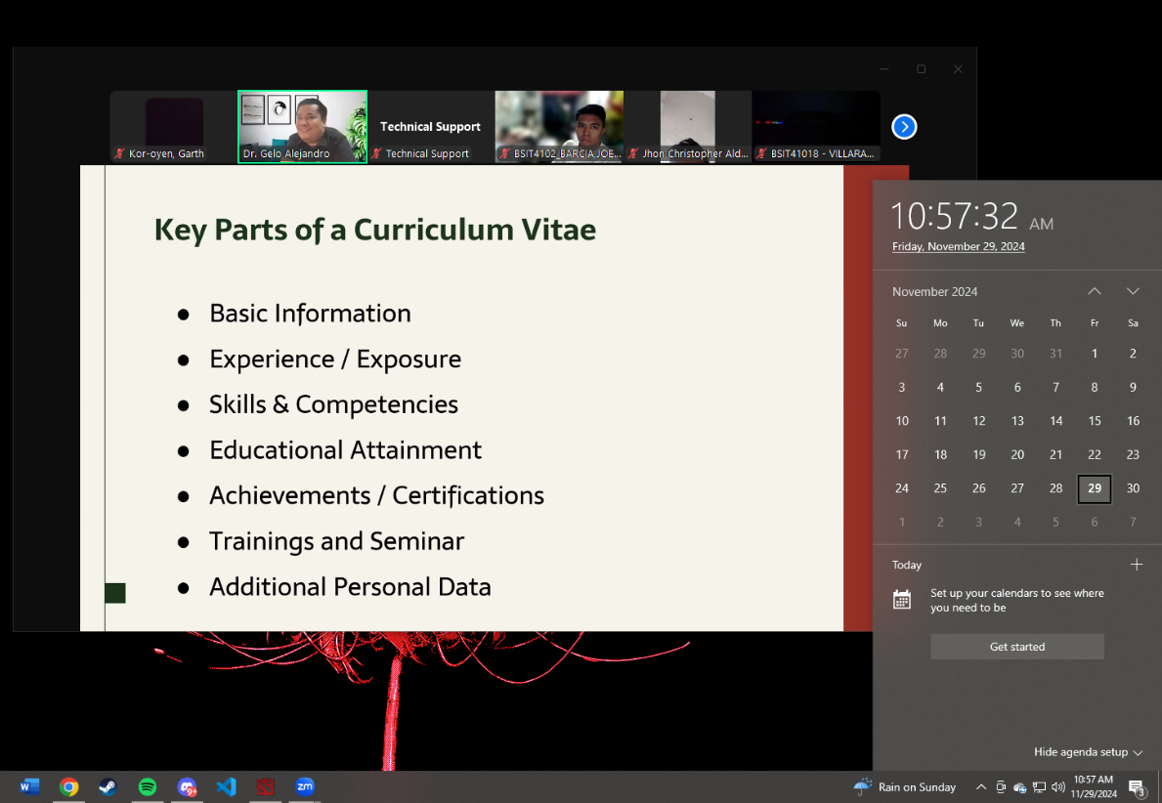

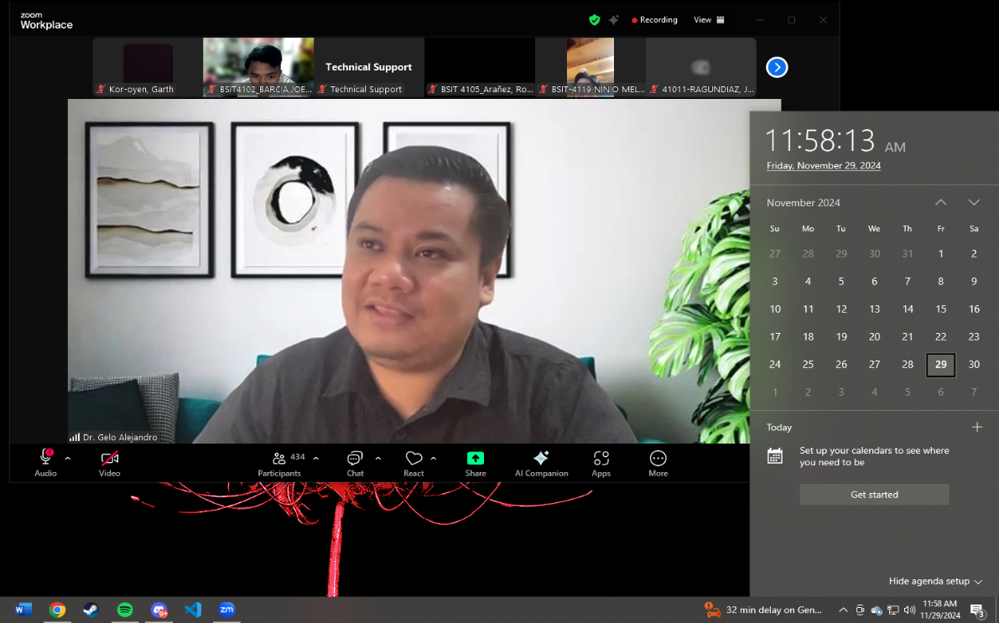

1. NARRATIVE REPORT – Is all about opportunities after our college life which is a good session with Dr. Alejandro, giving us idea and techniques when we looking for our job and careers.